Data Visualization – Book Notes

**Chapter 1) Foundations for an Applied Science of Data Visualization**

* + Mechanisms of the construction and storage of knowledge remain open questions (cognitive science)
  + Most cognition is done with interaction: tools, computers, individuals
  + Neurons find patterns in visual information
  + *Visualization:* current definition is graphical representation of data or concepts
  + Benefits of data visualization:

1. Enables comprehension of large quantity of data
2. Allows properties to emerge that weren’t easily noticed before
3. Brings problems/errors within data to light
4. Facilitates understanding of large-scale and small-scale features (?)
5. Can led to hypotheses
   * Process of visualization, 4 stages:
6. Data collection/storage
7. Pre-processing
8. Mapping (data 🡪 visual representation)
9. Perceiver
   * Environments in data-gathering loop:
     + Physical environment = source of data
     + Social environment = determines data to be collected and interpreted
   * *Semiotics* – study of symbols
   * Some think that pictures and visual representations are arbitrary (def. must be learned), unless given some correlation. Others think that the basic understanding of pictures (representations) is not a learned skill
   * Some graphical notations are more effective than others because, for example, our brain is designed to seek out continuous contours vs shapes
   * *Sensory –* symbols that use perceptual brain processing without learner
   * *Arbitrary –* aspects of representation that must be learned (ex. word “dog” = animal dog)
   * The interaction of the growing nervous system with everyday reality leads to a more or less standard visual system
   * Humans, cats, and monkeys have similar visual systems
   * Properties of Sensory Representation:
10. Understanding without training (ex. 3D surfaces)
11. Resistance to alternative denotation (ex. sensory persists despite knowledge of illusion)
12. Sensory immediacy (ex. rapid-processing systems like direction)
13. Cross-culture validity (ex. understood across boundaries)
    * Guidelines of graphic data representation:
14. Consider quick human sensory capabilities
15. Represent important data graphically and distinctly
16. Greater numerical quantities = more distinct (similar to G2)
17. Symbols should be standardized within and across applications
18. Choose tool that allows for most valuable work to be done per time unit
19. Adopt novel design solutions only when the estimated payoff > cost to learn them
20. Adopt tools consistent with other commonly used tools (unless G6 applies)
21. Effort spent developing **∝** profits expected to generate
    * “Arbitrary codes” aka language symbols are no bueno bc:
      + Hard to learn
      + Easy to forget
      + Are cultural
      + “formally” powerful (ex. math)
    * Gibson’s Affordance Theory: we perceive in order to operate on the environment. Perception is designed for action.
      + *Affordances* = perceivable possibilities for action
      + “We perceive surfaces for walking, handles for pulling, space for navigating, tools for manipulating, etc.…”
      + Tied to Theory of Direct Perception (we perceive immediately, not piecing together)
    * Other theorists think perception is a very active process
      + 3 problems with Gibson’s theory:
22. Visualization of data through computer graphics is indirect (abstract or tiny)
23. No clear physical affordances to any graphical user interface (buttons on screen must be learned)
24. Rejection of visual mechanisms is a problem (ex. color TV is based on these)
    * 3-Stage Model of Visual Information Processing:
25. Information is processed in parallel to extract basic features
26. Active process of pattern perception occurs (ex. colors, textures, motion)
27. Information is reduced to a few key objects held in working memory
    * Two-Visual System Theory: two systems:
28. *Action System* – for locomotion and action
29. *What System* – for object identification
    * *Attention*- multifaceted pervasive set of processes involving the entire visual system
      + Ex. when a new image flashes on a screen
      + Idea: “the effects of attention can be propagated outside of the brain into the world through cleverly designed interactive visualizations that cause information we are interested in to be highlighted on the screen” 🡨 whatever that means
    * Ultimate goal of interactive visualization design: to optimize applications so that they help us perform cognitive work more efficiently
    * Perspectives: have to consider costs
      + Developer
      + User
    * 2 Forms of Data:
30. *Entities –* objects we wish to visualize
31. *Relations –* define the structures and patterns that relate entities together

* *Attribute –* a property of some entity and cannot be thought of independently
  + Types of Numbers (“Steven’s Levels of Measurement”, underlined = widely used):
    - Nominal (labeling/categorical – ex. different fruits)
    - Ordinal (ordered/integer – ex. grades)
    - Interval (chronological – ex. time)
    - Ratio (can say “… is twice as large as …” – ex. money)
* Real-number data = ratio + interval scales
  + Showing uncertainty in visualization is important but also difficult to achieve
  + It is difficult to express *operations* effectively in a static diagram
    - Animation is useful!
  + *Metadata –* data about data
    - Who collected it, what transformations could have happened, uncertainty, etc….

**Chapter 2) The Environment, Optics, Resolution, and the Display**

* Visible light spectra: 400-700nm
* *Ecological optics –* (Another one of Gibson’s theories) focuses on properties of surfaces
  + Surfaces help us understand the potential for interaction and manipulation of environment
* *Ambient optical array* – (Also Gibson) describes the spherical array of light arriving from all directions at some designated point in the environment
  + One goal of computer graphics is to simulate the colors and rays that would pass through a glass rectangle on its way to a particular point
  + Just look at diagram below:

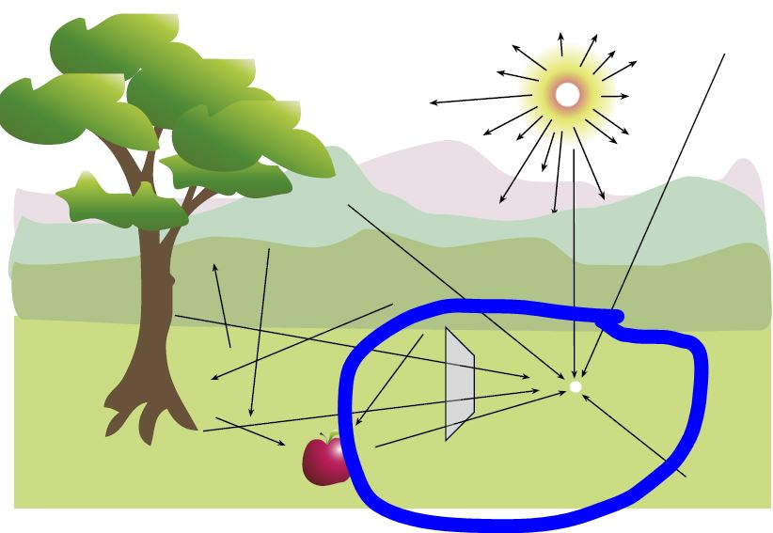

* *Optical flow –* dynamic character of the ambient optical array
* Texture helps us see where an object is and what shape it has
  + Texturing is not easy to do and could be irrelevant
* Shading types:

1. *Lambertian shading* – brightness of surface is only dependent on cosine of the angle
2. *Specular shading* – depends on viewing direction and the positions of the light sources
3. *Ambient shading –* light illuminates a surface from everywhere except actual light sources
4. *\*Cast shadows –* object can cast shadows

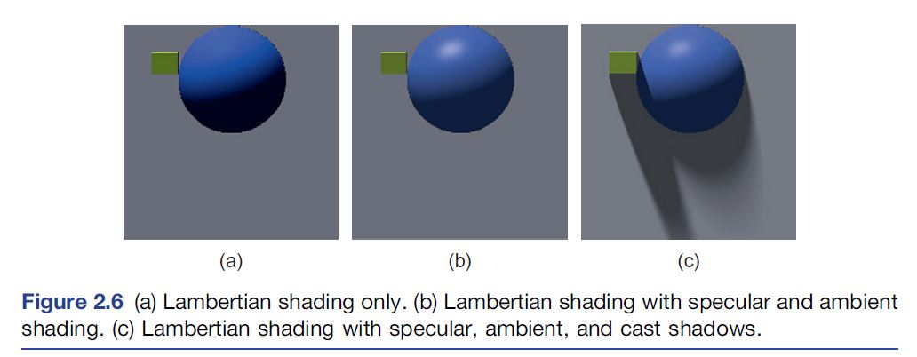

* Light Reflected (r) Towards a Particular Viewpoint Equation:

**r = a + b*cos(θ) + c*cosk(α)**

Where:

* + θ = angle between incident ray and surface
  + α = angle between reflected ray and view vector
  + a, b, c = ambient, Lambertian, and specular light amounts
  + k = degree of glossiness (higher k = shinier surface)
* lighting/shading can be useful in visualization of fine surface features
* Guidelines for lighting models:

1. Use Lambertian shading to reveal the shapes of smooth surfaces
2. Use specular shading to reveal fine surface details
3. Consider using cast shadows to reveal large-scale spatial relationships
4. Consider using ambient occlusion to support 2D shape perception for objects w/ no shading
5. Augmented-reality images should be same focal distance as reality to “link” to reality
6. Augmented-reality images should be closer focally than reality if no need to “link”
7. When using a HMD to read text, make the width no more than 18* of visual angle
8. Use a high-resolution display with a moderate viewing angle (ex. 40*) for data analysis
9. Use wrap-around screens to obtain a sensation of “presence” (realness) in a VR space.
10. Avoid high-contrast grating patterns in visual displays, especially if flickering
11. Antialias (smooth over jagged stuff) visualizations wherever possible

* *Ambient occlusion –* ambient light blocked from the inner depths of an object (think tunnel)
* The main parts of the human eye:
* Lens – reflects inverted image
* Pupil
* Retina
* The Visual Angle Equation:

**Tan(θ/2) = h/(2d) 🡪 θ = 2arctan(h/2d)**

* Imaging Properties of a Simple Lens Equation:

**1/f = 1/d + 1/r**

Where:

* + f = focal length of lens
  + d = distance to the object that is imaged
  + r = distance to image that is formed

*Note: other math stuff on page 43 and 44

* *Augmented-Reality –* superimposing visual imagery on the real world
  + Uses a “beam-splitter” device and results in double-exposed photograph, essentially
  + Usually, computerized imagery and real-life are same focal distances
  + If focal distances are different for both computerized imagery and real-life, user can choose to focus on one or the other to selectively attend.
* *HUDs* – aircraft heads-up displays; found that observes focus at a distance closer to infinity with HUDs, causing overestimation of distances to objects in the environment
* *HMDs* – head-mounted displays
  + Progressive glasses do not work
* *Virtual-Reality (VR) –* blocks out real world, only computerized imagery
  + Imagery makes sure objects at different focal distances appear correctly out of focus
* *Chromatic Aberration* – different wavelengths of light are focused at different distances within the eye (ex. red seems nearer than blue on a black background)
* Two receptor cells in the retina:

1. Rods – sensitive at low light, shutdown during daylight, far more than cones, all over retina
2. Cones – active in daylight, colors and details, less, packed at the fovea (center) of the retina

* *Visual Acuities* –measurements of our ability to see detail (ex. distinguish two lines)
* Binocular viewing improves acuity by 7% and 1.41x improvement in contrast sensitivity
* Motion sensitivity in the periphery is better than static sensitivity
* Visual eye chart: each letter is 5x smallest resolvable size for people with 20/20 vision.
* Found that size of smallest distinct characters is approximated by:

Character size Equation:

**Character Size = 0.046e**

Where:

* e = eccentricity (deviation from curve) from the fovea in degrees
* Retinal ganglion cells – neurons that send info from the eye up the optic nerve to the brain cortex
* *Axon –* nerve fiber of neuron that carries the signal
* *Receptive field –* visual area that feeds into the ganglion cell
  + Receptive Field Size Equation:

**RFS = 0.006(e + 1.0)**

Where:

* e = eccentricity (deviation from curve) from the fovea in degrees
* *TBP* = total number of brain pixels
* *USBP =* uniquely stimulated brain pixels
* Measuring Number of USBP:

**USBP = TBP – reductant brain pixels**

* Measuring Display Use Efficiency (DE):

**DE = USBP/SP (screen pixels)**

* Measuring Visual Efficiency (VE):

**VE = USBP/TBP**

* *CAVE:* Cave Automatic Virtual Environment – a virtual-reality display where the participant stands in the center of a cube, each wall of which is a display screen.
* A conventional monitor covers only 5-10% of our visual field, but stimulates 50% of our brain’s pixels
* The brain gets new visual information by making rapid eye movements of about 5* on average.
* *Sine Wave Grating* – tool for measuring basic properties of the human visual system.
  + 5 ways to vary pattern:

1. Spatial frequency (# bars of grating/*)
2. Orientation
3. Contrast (amplitude)
4. Phase angle (lateral displacement)
5. Visual area covered

* Grating Luminance Equation:

**L = 0.5 + (a/2)sin(2πx/ω + Φ/ω)**

Where:

* a = contrast (amplitude)
* **ω** = wavelength
* Φ = phase angle
* x = position on screen
* L = resulting output light level in range [0,1]
* Contrast (C) Equation, aka, the *Spatial Modulation Sensitivity Function*:

**C = Lmax – Lmin / (Lmax + Lmin)**

Where:

* Lmax = peak luminance
* Lmin = minimum luminance
* Fine detail and sensitivity to pattern decreases with age
* We are insensitive to low gradual (low frequency) variation, so we fail to notice poor projector quality when it varies over the screen
* Optimal sensitivity is obtained from a grating flickering at between 2 and 10 cycles/sec (Hz)
* Visual stress can cause convulsions and vomiting
* *Pattern-induced epilepsy* is a thing
* Optimal display: 100 or 150 pixels/degree
* *Nyquist limit* – a signal can be reconstructed from its samples only if the samples are obtained at a frequency at least twice the highest frequency contained in the course
* *Aliasing effects –* essentially, technique to smooth over jagged, stair-case like patterns
* Need 1200 dots/inch on a laser printer bc the dots of a laser printer are either black or white. To represent gray, many dots must be used.
* *Superacuties –* occur because the human visual system can integrate information from a number of retinal receptors to give better than receptor resolution
  + Antialising can result in superacuity performance
* *Temporal Antialising* – essentially smoothing out moving objects so that they appear as one unit